**DATABASES**

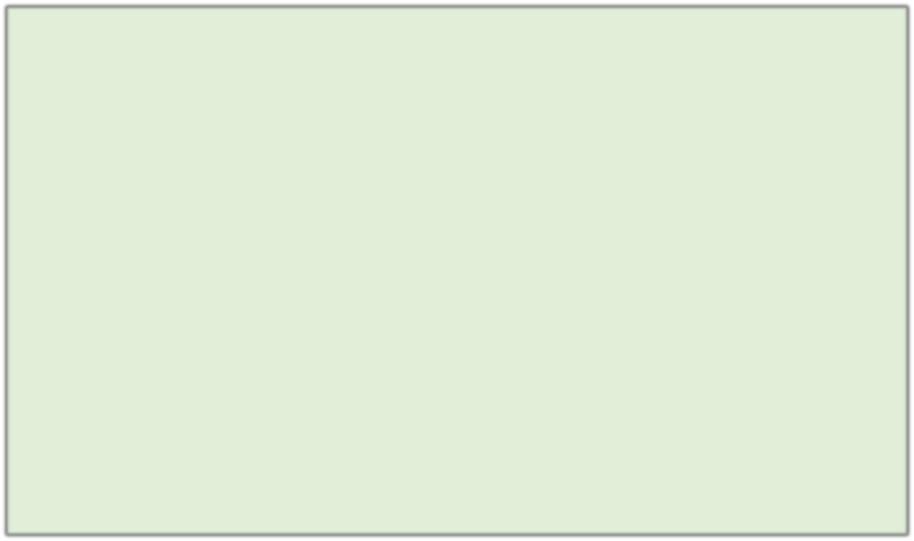

Unit 2 :

**Databases Logical Design**

**UNIT 2: DESIGN LOGICAL OF BASES OF GIVE COUGH**

1. **Model of data**
2. **The representation of the problem: the diagrams E/R**
   1. **Entities**
   2. **Attributes and guys**
   3. **Relations**
   4. **Cardinality**

Luis Herrero de Cos

* 1. **Weakness**

1. **Integrity referential and dependence functional**
2. **He model E/R extended.**
3. **Construction of a diagram E/R**
4. **The model relational**
   1. **Characteristics of a relationship.**
   2. **Keys primaries and keys alien**
   3. **Restrictions**
   4. **Representation of the scheme relational**
   5. **Passed of the diagram E/R to the model relational.**
5. **Standardization.**

**A model of data is a set of tools and rules for represent the data, the relations between these and the restrictions of one database.**

Fundamentally the following Models of

data have been used:

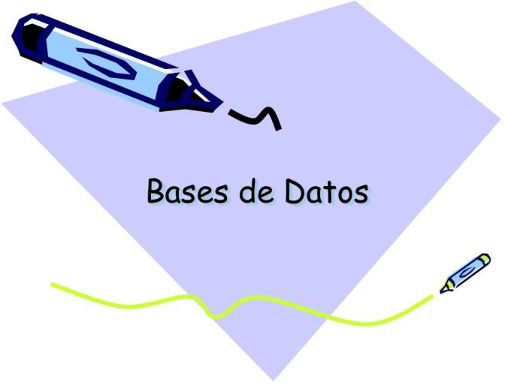

* Entity-Relationship
* Relational
* Hierarchical
* In grid
* Object Oriented
* Relational-objects oriented

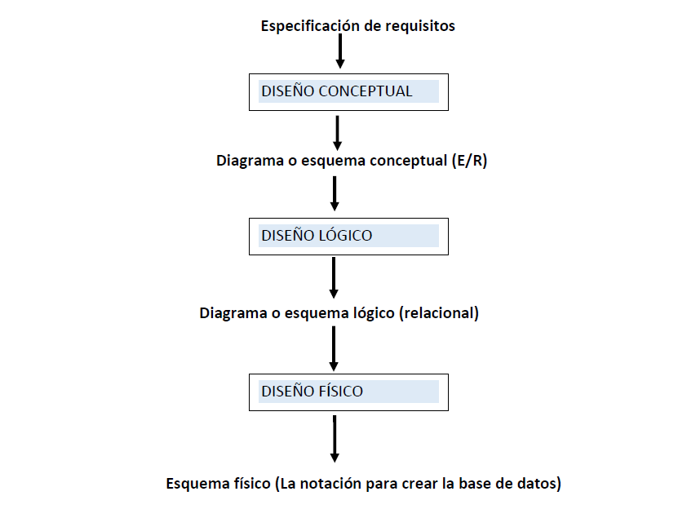

**The process of designing of a database, from the description of the functioning of the system until the implementation of the B.D.**

* The Entity-Relationship model is a purely conceptual model.
* It represents the functioning of a system of information through a diagram Entity Relationship (E/R).
* Facilitates enormously the design of one base of data. It is very representative of the functioning of the system of information.
* It takes as reference the perception we have of how it works in the real world

That perception is based in entities that act on others entities doing processes.

Consists of one collection of objects basic called ***entities*** and of

***relationships*** established between said entities.

* Several E/R models have been developed and diagrams of representation for said model.
* In this course we will use the model of Chen. This is a example of

E/R diagram that uses the rules representation _ of Chen.

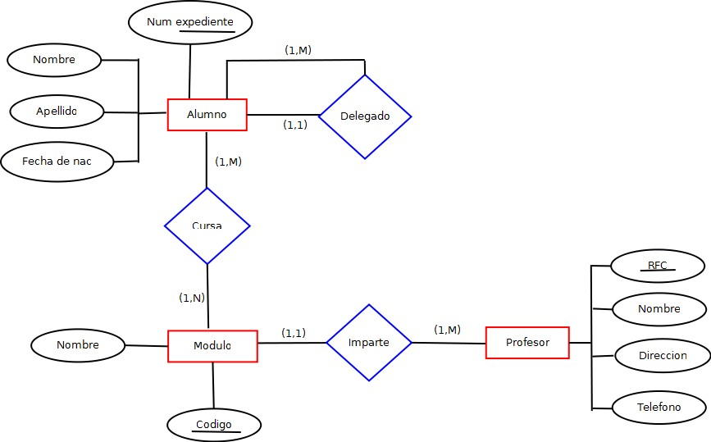

* The entities are one of the items used in the diagrams E/R.

#### A entity is a object, subject or concept about which is collected basic information so the system can carry out the processes required.

* In a system of information that allows manage the functioning of a school, entities could be:

STUDENT TEACHER SUBJECT COURSE

#### An entity is represented in a E/R diagram E/R a

***rectangle.***

STUDENT

TEACHER

COURSE

SUBJECT

**An attribute is a property or a feature of one**

**entity.**

As we will see further forward, the relations also can have

attributes.

For example, the entity STUDENT can have them attributes:

* Number

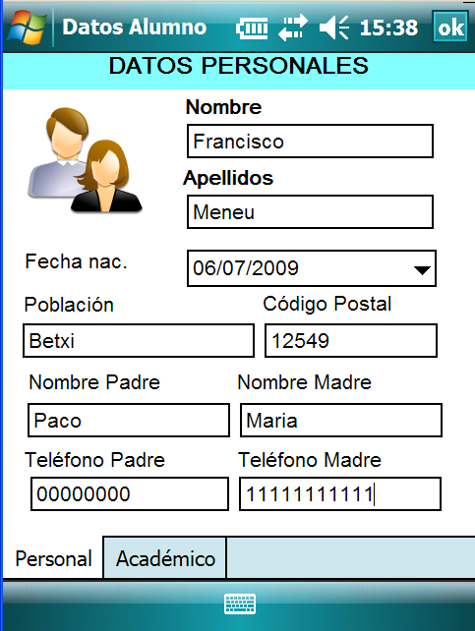

* Name
* Surnames
* Date Born
* Population

# 9

## The attributes of an entity are represented through little ones circles joined to the entity by a line. To the side of each circle the name of the attribute is written.

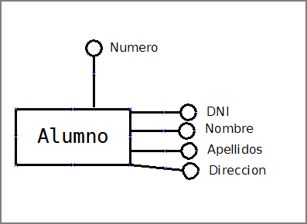

**Domains of the attributes**

*The* ***domain*** *of an attribute it's the whole set of values that can be assigned to that attribute.*

Examples of attributes and domains of an entity **EMPLOYEE:**

|  |  |
| --- | --- |
| **Attribute** | **Domain** |
| **ID** | Chain of characters of length 9 |
| **Name** | Chain of characters of length twenty |
| **Surnames** | Chain of characters of length 30 |
| **Antiquity** | Date |
| **Salary** | Number real with two decimals |
| **Category** | Listed of Categories |
| **Full time** | True False |

**Exercise 1:**

*Indicate which would be the domain of each one of the following attributes of the entity PERSON:*

* + *Date of birth*
  + *Location of birth*
  + *Age*
  + *He's older*
  + *ID*
  + *Telephones _*
  + *Name*
  + *Surnames*

**Kinds of attributes:**

**Simple and Composite attributes:** An attribute it's simple if your content cannot be considered to be divided in parts, by example NAME. Is composite if it admits to be divided in parts. By example, DATE could be composite if it is considered that from DATE we can isolate DAY, MONTH and YEAR.

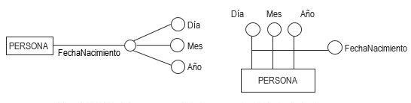

**Guys of attributes:**

**Monovalued and multivalued attributes:** An attribute is movalued if it only admits one value for each element of the entity, for examplename of a a person coulde be monovalued. If an attribute admits a list of values for each element, the it is multivalued. By example, if an attribute of the entity CUSTOMER was customer_phone, this could be a multivalued attribute

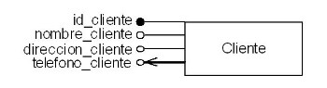

**Kinds ofattributes:**

**Mandatory and optional attributes:** An attribute is required if for each element has to contain some value and is optional if is allowed to have items with no assigned none value for that attribute. By example, the attribute **Hobbies** could be optional for an entity **CUSTOMER.**

An optional attribute is represented:

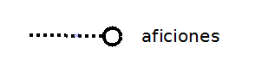

**Derivatives and No derivatives attributes:** An attribute is derivative if it can be obtained from the data that are in other attributes and it is no derivative if its value does not depend of other attributes. A derivative attribute could be Total_SOLD that can be calculated from UNITS SOLD and PRICE UNIT.

## Derivative attributes are not recommendable.

**Key** a key is used to identify in a unique way each element of an entity. It can be formed by only one attribute or several. In a key values cannot be repeated, that is to say, that there cannnot be two elements of the same entity with the same key. In an entity there may be two key types :

* **Primary Key:** Inside of the sets of attributes that may allow identify to the items of one entity, ought to be that is considered more appropriate in base to a series of requirements: **simplicity, length, representativeness, stability.**
* **Alternative key.** Ctherecan be several in an entity, but we should not abuse these keys They will be all those that we decide, apart from the primary.

**Representation of the attributes:**

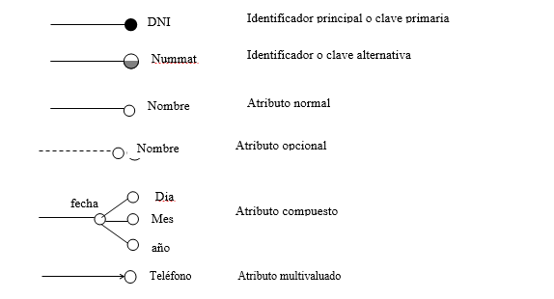

**Exercise 2:**

*Justify if the following attributes would be mandatory-optional, composite-simple, derived-not derivative, monovalued- multivalued.*

* + *Date of birth*
  + *Location of birth*
  + *Age*
  + *He's older*
  + *ID*
  + *Telephones _*
  + *Name*
  + *Surnames*